**Linear Search**

#include <stdio.h>

int linearSearch(int arr[], int size, int key) {

for (int i = 0; i < size; i++) {

if (arr[i] == key) {

return i;

}

}

return -1; }

int main() {

int n, key;

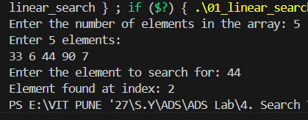

printf("Enter the number of elements in

the array: ");

scanf("%d", &n);

int arr[n];

printf("Enter %d elements:\n", n);

for (int i = 0; i < n; i++) {

scanf("%d", &arr[i]); }

printf("Enter the element to search for: ");

scanf("%d", &key);

int result = linearSearch(arr, n, key);

if (result == -1) {

printf("Element not found\n"); }

else {

printf("Element found at index: %d\n", result); }

return 0;

}

**Binary Search**

#include <stdio.h>

int binarySearch(int arr[], int size, int key) {

int left = 0;

int right = size - 1;

while (left <= right) {

int mid = left + (right - left) / 2;

if (arr[mid] == key) {

return mid;

}

if (arr[mid] < key) {

left = mid + 1;

} else {

right = mid - 1;

}

}

return -1;

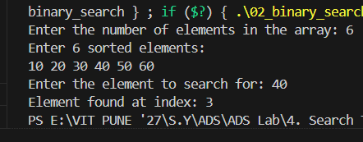

}

int main() {

int n, key;

printf("Enter the number of elements in

the array: ");

scanf("%d", &n);

int arr[n];

printf("Enter %d sorted elements:\n", n);

for (int i = 0; i < n; i++) {

scanf("%d", &arr[i]); }

printf("Enter the element to search for: ");

scanf("%d", &key);

int result = binarySearch(arr, n, key);

if (result != -1) {

printf("Element found at index: %d\n", result);

} else {

printf("Element not found\n");

}

return 0;

}